TESSA is an experimental system that aims to aid transactions between a deaf person and a clerk in a Post Office by translating the clerk’s speech to sign language. **[1]** (But they used British Sign language)

These systems are designed to provide translation of conversational speech between languages with a potentially very large vocabulary **[4].**

We have been developing a system which combines aspects of both kinds of systems mentioned above. It is an interactive translation system but it operates in a very restricted domain and is designed to assist in the completion of a transaction between a Post Office (PO) clerk and a deaf customer. **[1]**

The quality of TESSA's signing was measured in two ways: intelligibility of signs, and acceptability of signs to deaf users**. [1]**

1. Automatic speech to text conversion (speechrecognition);

2. Automatic translation of arbitrary English textinto a suitable representation of sign language;

3. Display of this representation as a sequence ofsigns using computer graphics techniques. **[1]**

Note that, because there is no separation of speech and language decoding in this system, it does not suffer from inaccuracies in the speech decoding process being forwarded to a language translation process that is also imperfect, an effect that can make more complex systems fail to translate correctly even quite simple phrases. By using pre-stored phrases, in effect we trade flexibility and range for accuracy. **[1]**

Table 1 shows the percentage of phrases that were rated in each category of acceptability. The average acceptability rating was 2.2 and ranged from 1.7 to 2.8. **[1]**

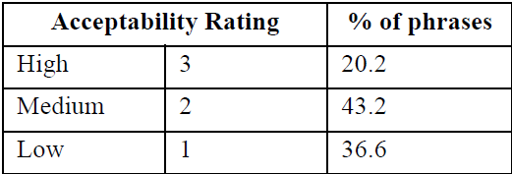

However, for many people who have been profoundly deaf from a young age, signing is their first language so they learn to read and write English as a second language **[2]**

As a result, many deaf people have below-average reading abilities for English text and prefer to communicate using sign language **[3].**

**References**

1. *Cox, S., Lincoln, M., Tryggvason, J., Nakisa, M., Wells, M., Tutt, M. and Abbott, S., 2002, July. Tessa, a system to aid communication with deaf people. In Proceedings of the fifth international ACM conference on Assistive technologies (pp. 205-212). ACM.*
2. *R. Conrad. The deaf school child. Harper and Row, 1979.*
3. *D. Wood, H. Wood, A. Griffiths, and I. Howarth. Teaching and talking with deaf children. John Wiley and Sons, 1986.*
4. *A. Waibel. Interactive translation of conversational speech. Computer, 29(7), 1996.*